[Organisation] · PHASE C · TEMPLATE T-06
Architecture Definition Document
Data Architecture
Baseline, target, authoritative source and the lineage that does not exist
Field | Detail
Version | 0.1 — Draft
Date | July 2027
Cycle | First ADM cycle, Phase C — Data
Owner | Data Domain Architect (vacant — held by the Chief Enterprise Architect)
Approver | Data Governance Council, then Architecture Board
Template | T-06 Data Architecture Definition
Classification | Internal

Contents
1. Scope and viewpoints
2. Baseline data architecture
3. Target data architecture
4. Authoritative source designation
5. Classification, lawful purpose and retention
6. Regulatory lineage
7. Data quality rules and measurement
8. Gap analysis
9. Migration implications
10. Stakeholder review
11. Open items
12. Findings
13. Approval

Two of the ten template sections cannot be completed
Regulatory lineage and data quality measurement both depend on things that do not exist. They are marked incomplete rather than filled. Gaps and work packages are read from metamodel O29 and O30; nothing in this document is authored that a register already holds.

1. Scope and viewpoints
 | Detail
In scope | The 24 data entities in the enterprise information model, the 12 logical and 18 physical components that hold them, and the 9 data sets assembled from them.
Out of scope | Reference data and code lists, which are not modelled as entities. Investment and treasury data, which follows the Phase A scope exclusion.
Level of detail | Entities to key attribute. A full attribute model belongs in the physical design and is not attempted here.
Time horizon | Baseline as at June 2027. Target as at December 2030, with the Wave 2 position called out where a work package lands earlier.

1.1 Viewpoints used
Viewpoint | Artifact | Content | Principal stakeholder
Conceptual | Information Map and Conceptual Data Model | 24 concepts, 11 subject areas, 31 relationships | Chief Data Officer, the business
Logical | Conceptual and Logical Data Model | 161 attributes, 12 logical components | Data Domain Architect
Physical | Data Architecture, baseline and target | 18 physical stores across five technologies | Application and Technology architects
Mastering | Master Data Model | 9 master entities, 12 mastered including contracts | Data Governance Council
Lifecycle | Data Lifecycle | 6 stages, 24 retention obligations | Compliance, Chief Risk Officer
Security | Data Security | 3 classifications, 8 controls | Security Domain Architect, Chief Risk Officer
Metadata | Conceptual Metadata Model | 22 elements in 4 categories | Data Domain Architect
Traceability | Information to Data Catalogue, Information Source Map | 6-link chain, concept to data set | Data Governance Council

2. Baseline data architecture
As at June 2027, including what works. Each row references the artifact holding the detail.

Layer | Position | What it means
Entities | 24 entities in 11 subject areas, every one named and defined by the business. | Three have no logical component: Life Assured, Beneficiary and Scheme.
Logical | 12 logical data components. Six are Target state. | Three have no physical store at all: Product Catalogue, Conduct Record Store, Regulatory Reporting Store.
Physical | 18 physical stores on DB2, Oracle, SQL Server, PostgreSQL and object storage. | Every one resolves to a logical component. No orphan store.
Mastering | 44 Master and 5 Copy relationships across 26 applications. | Ten entities are sourced from more than one application; Party and Customer from five each.
Movement | 50 recorded interfaces, 44 of them unmanaged, 20 of them batch files. | Four read another application's database directly. The estate is estimated at 60, so the register is 83% complete.
Quality | Poor on 4 entities, Fair on 14, Good on 6. | A judgement, not a measurement. Nothing measures data quality anywhere.
Lifecycle | Create 18, Validate 8, Use 17, Maintain 11, Archive 5, Dispose 0. | Every entity carries a retention obligation and nothing disposes of anything.
Metadata | 22 elements assessed; 10 held in full, 7 absent. | Lineage is among the absent. Fourteen elements are held in a spreadsheet.
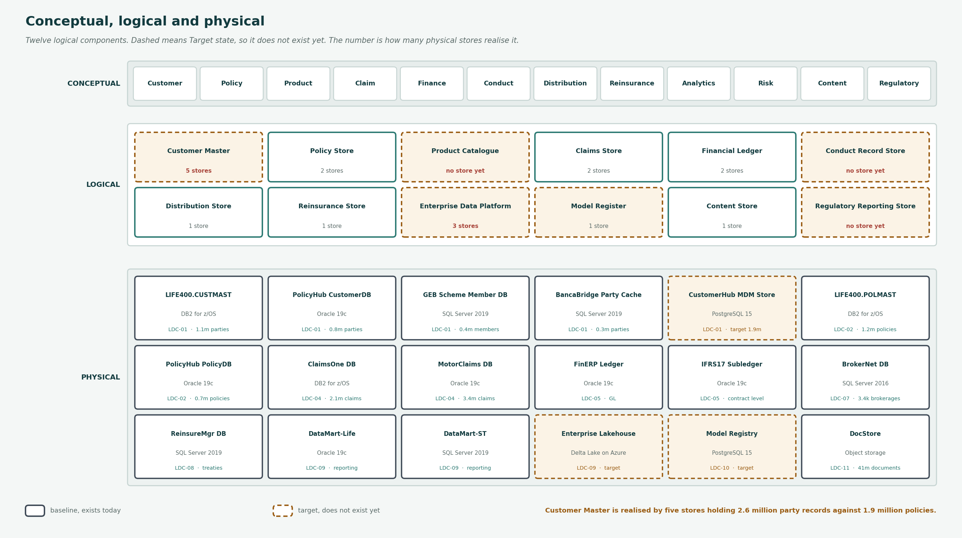
Figure 1 — Conceptual, logical and physical. Dashed is Target state.

3. Target data architecture
Layer | Target | How it is reached
Entities | Every entity placed in a logical component and consumed by something, or explicitly recorded as operational only. | Three placements and five consumption decisions.
Logical | The three target components built: product catalogue, conduct record store, regulatory reporting store. | Each corresponds to work the business already does on spreadsheets.
Physical | Customer identity resolved across the four masters without replacing any of them. | Registry style under ADR-031. The masters stay live.
Mastering | One designated authoritative source per entity, and no entity contested. | Designation by the Data Governance Council, which gates WP-04.
Movement | Every new interface on the managed layer; the four direct database reads removed first. | WP-02 Integration Platform Foundation.
Quality | Measured rather than judged, against stated rules, for the entities that carry a regulatory obligation. | Not yet scoped. See section 7.
Lifecycle | Disposal implemented for every entity carrying a retention obligation. | No work package exists for this.
Metadata | Lineage captured from source to reported figure. | WP-06 Enterprise Data Platform, and only after the platform's footprint is recorded correctly.

4. Authoritative source designation
One system of record per entity. Six entities need a decision; the other eighteen already have a single source and are not repeated here.

Ref | Entity | Today | Systems claiming authority | Proposed designation | Decides | Gates
DEN-01 | Party | CONTESTED | LIFE/400, PolicyHub-ST, SchemeAdmin, BancaBridge, CustomerHub | CustomerHub, once built. Until then no system is authoritative and the register should say so. | Data Governance Council | WP-04
DEN-02 | Customer | CONTESTED | Same five as Party | Follows Party. A customer cannot be more authoritative than the party it resolves to. | Data Governance Council | WP-04
DEN-03 | Contact Detail | CONTESTED | LIFE/400, PolicyHub-ST, CustomerHub | CustomerHub, with most-recently-verified survivorship. | Data Governance Council | WP-04
DEN-12 | Advice Record | SPLIT | CRM-Agent, BrokerNet, WebQuote | Conduct Record Store, once built. The FAIS obligation makes this urgent rather than tidy. | Chief Compliance Officer | WP-05
DEN-23 | Model | NONE | No system holds it | Model Registry. There is nothing to designate until an inventory exists. | Chief Risk Officer | WP-12
DEN-08 | Product Definition | SPLIT | LIFE/400, PolicyHub-ST, ProductStudio | Product Catalogue, once built. Nine products hold their rules in code, not data. | Chief Underwriting Officer | WP-08

Designation is a decision, not a delivery
It costs nothing and gates WP-04 Customer Master Data Management at R96.4m. The Data Governance Council did not reach quorum at the review, so nothing has been designated and the table above remains a recommendation.

5. Classification, lawful purpose and retention
Measure | Position
Classification | 4 Restricted, 17 Confidential, 3 Internal
Personal information | 11 attributes flagged across 6 entities
Retention obligation | All 24 entities, under POPIA, FICA, FAIS, the Companies Act, the Insurance Act or IFRS 17
Lawful basis | Stated for all 9 data sets. Not held at entity or attribute level
Consent | The attribute exists on Contact Detail and is not populated. No consent metadata is held anywhere
Disposal | No process in the estate disposes of any entity

Retention is recorded and disposal is not performed
Retention obligations were added to the Data Entity type at metamodel v1.17 under CR-030. Recording the obligation does not discharge it. POPIA section 14 does not permit personal information to be kept longer than necessary, and there is no work package for disposal.

6. Regulatory lineage
The template asks for: Per return, from line item to source system, with every transformation named.
This section is incomplete.
No lineage metadata is held anywhere in the estate. The metadata assessment records it as absent, and the data platform is recorded in R21 against three entities while nine data sets draw on nineteen.
The section cannot be written until the platform's actual footprint is recorded. That is a data-capture exercise, not a work package, and it gates every lineage question.

7. Data quality rules and current measurement
The template asks for: Rules per entity, with what is measured today.
This section is incomplete.
Quality is held as a judgement of Poor, Fair or Good against each entity, with no rule and no measurement behind it.
Writing rules is straightforward. Measuring against them needs the platform. Stating a rule with no measurement would give the section the appearance of completeness.

8. Gap analysis
Six gaps in the Data domain, read from metamodel O29. Every one is addressed by a work package from O30.

Ref | Gap | Type | Severity | Addressed by
GAP-01 | No single customer identity | New | Critical | Customer Master Data Management
GAP-02 | No customer timeline | New | Critical | Customer Timeline & Conduct Evidence
GAP-03 | No enterprise data platform | New | High | Enterprise Data Platform
GAP-04 | No data ownership register | New | High | Data Governance Foundation
GAP-12 | Spreadsheet regulatory assembly | Eliminate | High | Enterprise Data Platform
GAP-18 | No climate exposure integration | New | Medium | Climate Exposure Integration

8.1 The work packages that close them
Ref | Work package | Wave | Cost Rm | Benefit Rm p.a. | Owner
WP-03 | Data Governance Foundation | Wave 1 | 12.6 | 4.1 | Chief Data Officer
WP-04 | Customer Master Data Management | Wave 2 | 96.4 | 58.3 | Chief Data Officer
WP-05 | Customer Timeline & Conduct Evidence | Wave 2 | 38.2 | 19.6 | Chief Compliance Officer
WP-06 | Enterprise Data Platform | Wave 2 | 74.1 | 31.4 | Chief Data Officer
WP-14 | Climate Exposure Integration | Wave 3 | 22.8 | 9.9 | Chief Risk Officer

9. Migration implications
Noted, not designed. Migration is sequenced in Phase E; the Data Migration artifact holds the source-to-target mapping.

Implication | Detail
Six migrations follow from this target | Three where a baseline store has a named target, three where a target component has no store at all.
No migration retires a source | All four customer masters stay live after the identity work, by design under ADR-031. The estate grows.
Not one quality gate can be met today | Every migration has a stated gate and every gate is currently unmet.
Two migrations have no source system | The model register and the product catalogue are discovery exercises that produce data, then load it.
Advice Record carries a different risk class | A FAIS record lost in migration is a regulatory event, not a data quality incident.

10. Stakeholder review
Reviewer | Date | What they said | What changed
Chief Data Officer | 2027-07-08 | Accepted the baseline. Objected that designation was presented as part of WP-04 rather than ahead of it. | Changed. Designation is now shown as a Council decision gating WP-04, with the cost of the package stated beside it.
Chief Compliance Officer | 2027-07-09 | Accepted the classification and retention sections. Asked that the FAIS position on Advice Record be stated in the designation table rather than only in the findings. | Added to the designation row for DEN-12.
Chief Risk Officer | 2027-07-13 | Raised that the disposal gap has no work package and no owner. | Not changed in this draft. Recorded as an open item and as a finding; the gap register is not amended by this document.
Security Domain Architect (interim) | 2027-07-14 | Accepted the security section as the data layer of the security architecture. | No change.
Data Governance Council | 2027-07-15 | Two of five members attended. No quorum, so nothing was designated. | Not changed. The designation table remains a recommendation.

11. Open items
Item | Severity | Detail | Action and owner
The Data Governance Council did not reach quorum | High | Two of five attended the review. Nothing has been designated, and designation gates R96.4m of Wave 2. | Reconvene before the roadmap is approved. Chief Data Officer.
Disposal has no work package and no owner | High | Every entity carries a retention obligation. No process disposes of anything, and O29 holds no gap for it. | Add to the gap register or accept explicitly. Chief Risk Officer.
The data platform footprint is recorded against three entities of nineteen | Medium | Relation R21 under-records APP-22. Lineage cannot be captured for a footprint that is not recorded. | Data-capture exercise. Data Domain Architect.
The Data Domain Architect post is vacant | Medium | Phase C is being run by the Chief Enterprise Architect. The post has been vacant since 2026. | Carried from the Statement of Architecture Work, where 120 days were recorded against it.

12. Findings
Two of the ten template sections cannot be completed
Regulatory lineage and data quality measurement. Both depend on things that do not exist.
They are marked incomplete rather than filled. A lineage section written from the interface register would describe 50 interfaces of an estimated 60 and would be quoted afterwards as if it were complete.
Four entities cannot be designated today, and one of them is the reason
Party, Customer and Contact Detail are contested across five systems. Advice Record is split across three.
Designation is a Council decision, not a platform delivery. It costs nothing and gates WP-04, which is R96.4m. That ordering should be explicit in the roadmap and currently is not.
Eleven of twenty-four concepts trace from business definition to data set
Thirteen break at one of five points, and the breaks need five different owners.
The chain is what makes the data architecture testable. Before it existed each break was known to a different artifact and to nobody in one place.
The data baseline is honest about what it does not know
Quality is a judgement. The interface register is 83% complete. The data platform is recorded against three entities of nineteen.
Each is stated in the baseline rather than smoothed. A baseline that claims more precision than it has produces a gap analysis that is confidently wrong.
Nothing disposes of anything, and no work package covers it
24 entities, 24 retention obligations, zero delete operations, and no gap in O29 for disposal.
This is the one material exposure in the data architecture that the roadmap does not touch. It should either be added to the gap register or explicitly accepted by the Chief Risk Officer.

13. Approval
This document is a recommendation. Two of its thirteen sections are incomplete and are marked as such. Four items remain open, two of them High, and the Data Governance Council has not reached quorum to designate an authoritative source for any entity.

Role | Name | Signature | Date
Data Domain Architect | vacant — held by the Chief Enterprise Architect
Chief Data Officer | Pieter van Zyl
Chair, Data Governance Council
Chair, Architecture Board

Referenced artifacts
- Data Architecture baseline and target · Conceptual and Logical Data Model · Data Entity / Business Function Matrix
- Data Lifecycle · Data Migration · Data Security · Master Data Model · Conceptual Metadata Model
- Information to Data Catalogue Traceability · Information Source Map · Data and Application Models · Information Systems Landscape
- Metamodel O29 Gap and O30 Work Package registers

